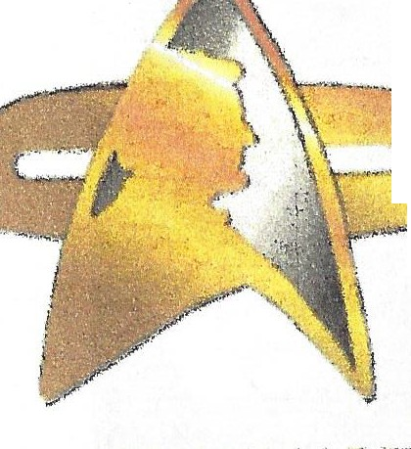
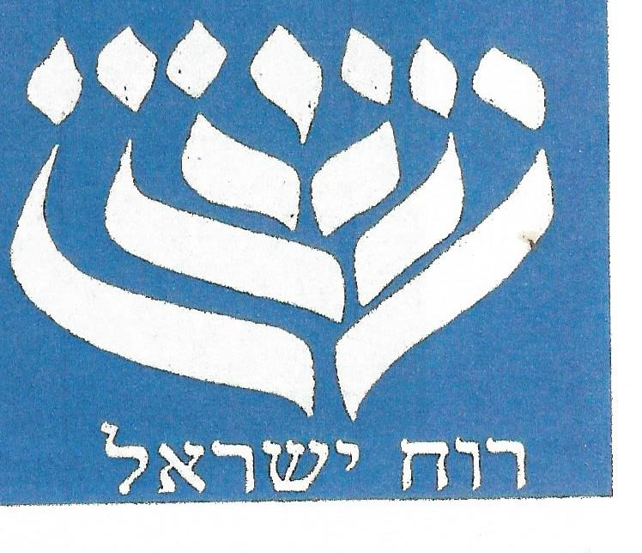
MJC Men’s’ Club &
USS Abraham Lincoln
USS ABRAHAM LINCOLN
NCC 71809

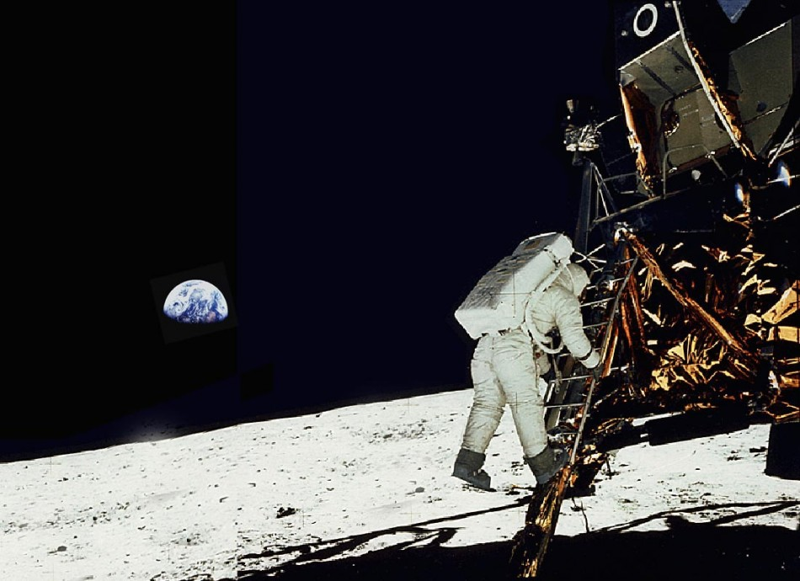

Celebrate the 50th Anniversary of the
APOLLO 11 Moon Landing
June 23, 2018 from 10 am - 6 pm

KEYNOTE GUEST:
Joe Lennox - Collector & Expert on NASA & Space Memorabilia (sponsored by Michael Specht – Supervisor Town of Ramapo)
Activities Include: Panels w/ Q & A, Videos, Guests, and Raffles

Advance tickets: $15 Adult / $10 Children under 13 (At Door $20/$15)
RSVP: Keith Shikowitz at starbase63@aol.com (in subject put MJC APOLLO 11 EVENT) or call the MJC Office at: (845) 357-2430

Make Checks Payable to: MJC Men’s Club - Address:
Montebello Jewish Center
34 Montebello Road, Montebello NY 10901

Refreshments will be available for purchase: Hamburgers, Hot Dogs, Soda (Chips, Salad and Condiments included)

PLEASE DO NOT BRING IN ANY OUTSIDE FOOD

